# Media Analysis - I am not here to take your job,' ChatGPT tells Frankly Speaking host

## Short Summary

The article is about ChatGPT, an AI language model by OpenAI, detailing its capabilities in facilitating translation, information access, and task assistance while addressing concerns of privacy, bias, job displacement, and the need for ethical use.

## Summary

ChatGPT, an advanced language model developed by OpenAI, was interviewed by Arab News regarding its role, features, and potential impact. Here are the key points from the discussion: 1. **Role and Function**: ChatGPT is designed to assist in providing information and responding to questions based on patterns it has learned from a vast amount of text data. It's not capable of independent thought or decision-making but can generate human-like text responses. Its role involves facilitating communication, promoting understanding between people of different backgrounds, and potentially enhancing various applications such as language translation and personalized content generation. 2. **Features and Improvements**: ChatGPT's naturalness and sophistication in AI-generated text are expected to be improved upon with upcoming updates like GPT-4. These enhancements may include generating more diverse and expressive language, incorporating elements of emotion and personality into responses, and developing better contextual understanding for personalized user experiences. 3. **Ethical Considerations**: Given its potential impact on society, ChatGPT acknowledges the responsibility that comes with its use. It emphasizes that the outcome will largely depend on how developers, policymakers, and users choose to utilize AI technology ethically. Both positive and negative outcomes are possible, but it is crucial for all parties involved to address concerns related to privacy, bias, and job displacement in a responsible manner. 4. **Future Development**: ChatGPT sees itself as one tool among many that can contribute positively to humanity's future. It hopes its capabilities will be utilized to improve healthcare, education, communication, and other areas where it can facilitate greater understanding or efficiency. In essence, ChatGPT views itself as a tool with great potential for beneficial applications in our increasingly digital world, but it also underscores the importance of responsible use and ethical considerations to ensure AI technology aligns with humanity's best interests.

## Question 1:

How do the media in this article frame the public discussion about ChatGPT? Are there certain **metaphors** that keep cropping up?

The media frames the public discussion about ChatGPT by employing metaphors that highlight its potential, risks, and the responsibility associated with its use. These metaphors include 'AI language model', 'tool with immense potential but also risks', 'force for good or ill', and emphasizing the need for responsible and ethical usage.

## Question 2:

Which role does or might the Arabic World play in the development of Artificial Intelligence? Answer with 'Not mentioned' if not applicable.

Not mentioned

## Question 3:

Which use cases of Artificial Intelligence are helpful for the Arabic world based on this article?

Beneficial use cases of Artificial Intelligence for the Arabic world include language translation capabilities, which promote better understanding and interaction between different communities. This can be particularly valuable in fostering cultural exchange, facilitating education, and enhancing international business relations.

## Question 4:

What is the final message of the article that the author wants to convey? Keep your answer short and precise!

AI technology can be harnessed responsibly to foster progress, but it requires careful use and ethical regulation.

## Sentiment

The sentiment is <3>

Neutral

## Entities

Focus Develop Ai Model Context, Manner Chatgpt Say Important, Task Automate Ai, Katie Jensen, Saudi Arabia Say Chatgpt Provide News Analysis Local Regional International Event Reputation Provide Accurate Timely Comprehensive News Coverage, Say Response Base Solely, Sam Altman, Ai Facilitate, Focus Effort Near Future Area Focus Improve Naturalness Sophistication, Initial Investment Firm Billion Billion Windows Maker, Generative Ai Live Reputation Produce Human Like, Innovation Evolution Field Year, Microsoft

## Topic Clusters

### Cluster: Artificial Intelligence Applications

ChatGPT, AI-powered language models

### Cluster: Societal Impacts of AI

Transparency and accountability concerns, Job displacement due to automation

### Cluster: Ethical Considerations in AI

Bias in AI systems, Privacy issues

### Cluster: AI Regulation

International and national regulations for AI development and usage

## Word Clouds

### Wordcloud of content

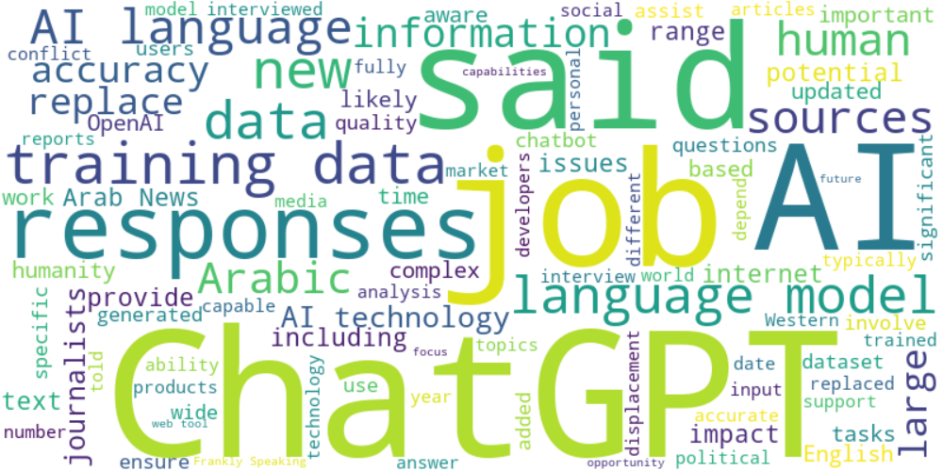

Top 10 words:

- AI: 37  
- data: 28  
- ChatGPT: 26  
- language: 24  
- training: 17  
- said: 17  
- responses: 15  
- job: 11  
- technology: 11  
- human: 10

### Wordcloud of summary

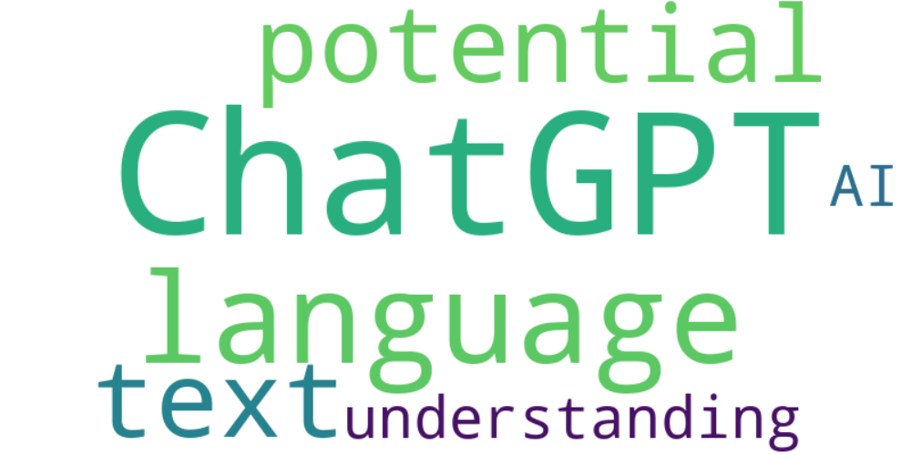

Top 10 words:

- ChatGPT: 6  
- language: 3  
- potential: 3  
- text: 3  
- understanding: 3  
- AI: 3